Content
Overview 1
Benefits 2
1. Centralized Data Storage 2
2. Schema Flexibility 2
3. Various Capabilities 2
Prerequisites 2
Setup 3
1. Clone the Repository, if you haven’t already done so: 3
2. Restore Dependencies: 3
3. Verify MongoDB is Installed and Running: 3
4. Build & Run the Project: 3
Results 3
Considerations for Streetcode 4
1. Configuration & Environment Separation 4
2. Dependency Injection (DI): 4

Overview
PoCStoringToponyms is a proof-of-concept (PoC) project demonstrating how to store Toponym data in MongoDB. It features a repository pattern to abstract data access, and includes a simple example of converting a list of Toponyms into JSON and saving them both in the database and as a .json file.
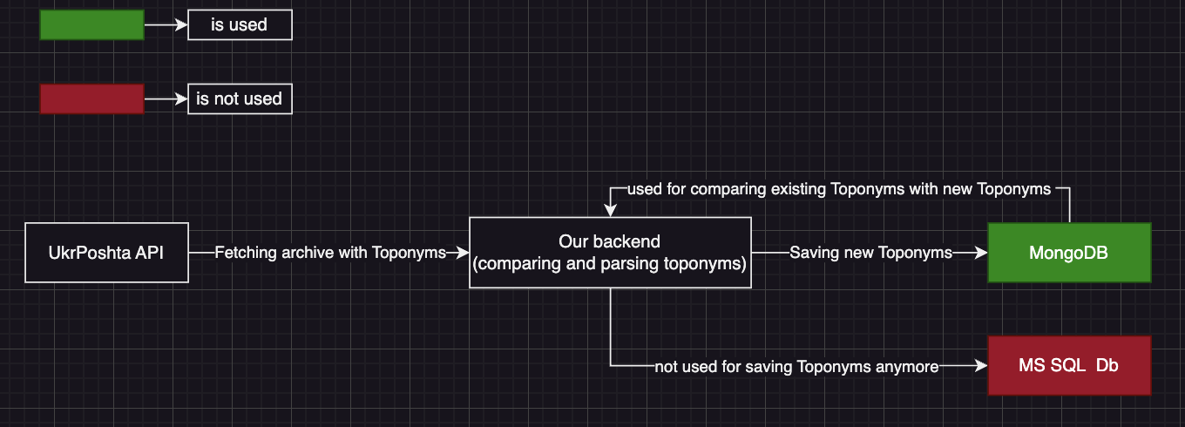
[Streetcode Architecture Diagram]

Benefits

Centralized Data Storage
MongoDB provides a single source that can be accessed from any machine or environment. This eliminates issues with version mismatches or data duplication that often occur with local stored files.

Schema Flexibility
As a document-oriented database, MongoDB naturally handles JSON-like data structures. That means Toponyms with various fields can be stored and extended.

Various Capabilities
Unlike flat files, MongoDB enables advanced querying, filtering, and aggregation, allowing faster and more efficient access to Toponym data.

Prerequisites
.NET 7 SDK (or later)
MongoDB:
Option 1: Install MongoDB locally.
Option 2: Use Docker and run the MongoDB container:
MongoDB.Driver NuGet Package
Newtonsoft.Json NuGet Package

Setup

Clone the Repository, if you haven’t already done so:
git clone <repo-url>
cd PoCStoringToponyms

Restore Dependencies:
Make sure you’re in the project’s root directory, then run:
dotnet restore

Verify MongoDB is Installed and Running:
Local Installation: Ensure the MongoDB service is started.
Docker:
docker pull mongo:latest
docker run -d --name mongodb -p 27017:27017 mongo:latest
Check if the container is running with:
docker ps
You should see the mongodb container running.

Build & Run the Project:
dotnet build
dotnet run

Results
As a result you will connect to the MongoDB instance at mongodb://localhost:27017, insert sample Toponym data into the ToponymsDb database and save a JSON file (toponyms.json) locally with the same sample data.

Considerations for Streetcode

Configuration & Environment Separation
Move the MongoDB connection string and database name out of hard-coded strings into configuration. For instance, store them in appsettings.Development.json or environment variables.

Dependency Injection (DI):
Register the MongoDB client and your repository in the DI container in Program.cs.

